- Aaklan GM Side : Aaklan First Page
  - Under Basic Detail Page below Increment section:
    - Create a section with Heading Power Consumption Details
    - Add 3 Columns from Aaklan contractor page
        - Intermediate Raw Water Demand (MLD)
        - Approved Power Guarantee Variable for Intermediate Raw Water Demand
        - Power Consumption per Day per MLD for Variable Components
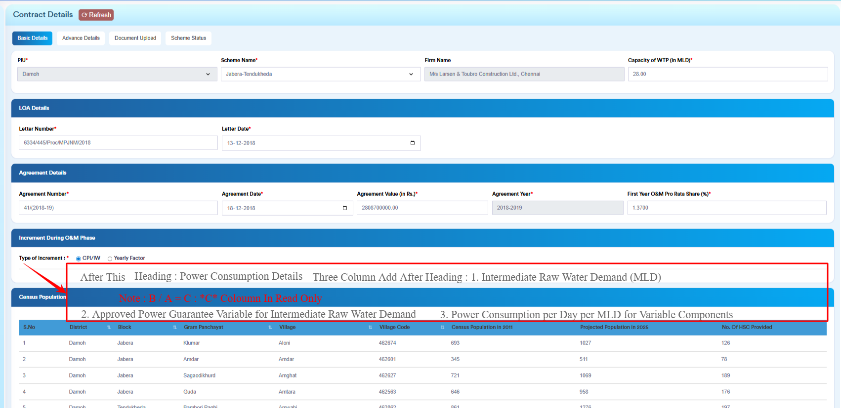

- On 4th Page Scheme Status
